CSE 4571 – PRACTICAL ROBOTICS PROJECTS WITH ARDUINO
EXPERIMENT 2
ANALOG SENSOR INTERFACING AND REAL-TIME DATA ACQUISITION
Duration | Level | Mode | CO Mapping
2 Hours | B.Tech CSE Final Year | Hardware / Wokwi | CO1, CO2, CO5
1. Aim of the Experiment
To interface an analog sensor with Arduino UNO, acquire ADC data and study its response to changing illumination.
2. Learning Objectives
- Understand ADC-based acquisition.
- Read a Wokwi photoresistor.
- Observe sensor response at different lux values.
- Use Serial Monitor/Serial Plotter for visualization.
3. Components / TinkerCAD or Wokwi Parts
Component | Quantity | Purpose
Arduino UNO | 1 | Microcontroller / ADC
Photoresistor module | 1 | Analog illumination sensor
LED | 1 | Threshold indication
220 Ω resistor | 1 | LED current limiting
Breadboard | 1 | Circuit assembly
Jumper wires | As required | Interconnections
4. Theory
Arduino UNO provides 10-bit analog inputs. The Wokwi photoresistor module exposes AO, whose voltage varies with simulated illumination. This experiment introduces acquisition, thresholding and simple calibration.
ADC value = analogRead(A0) → 0 to 1023
Approx. voltage = ADC × 5.0 / 1023.0
5. Pre-Lab Questions
- What is ADC resolution?

- What does analogRead() return?

- Why is calibration important?

- Why is A0 used for the photoresistor signal?

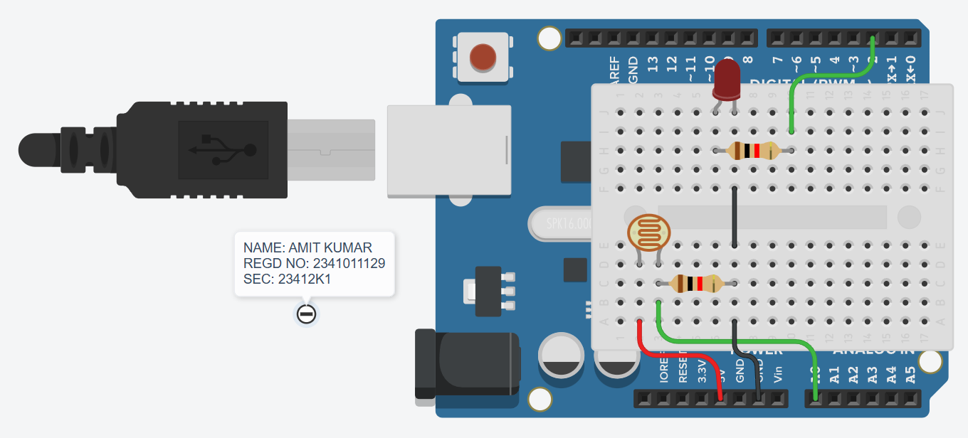
5. Circuit Diagram
Figure 1. Arduino UNO, TinkerCAD/Wokwi photoresistor module and LED threshold indicator.
6. Connection Table
Component / Signal | Arduino Pin | Connection Details
Photoresistor AO | A0 | Analog input
Photoresistor VCC | 5V | Supply
Photoresistor GND | GND | Common ground
LED Anode (+) | D2 | Through 220 Ω resistor
LED Cathode (−) | GND | Ground
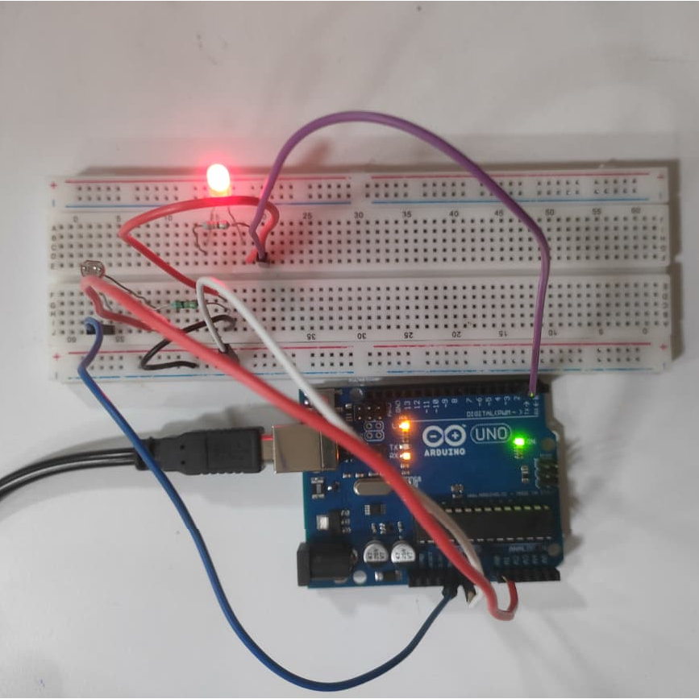
7. Circuit Diagram Implemented Using Hardware’s
Figure 2. Hardware Implementation of Arduino UNO, TinkerCAD/Wokwi photoresistor module and LED threshold indicator.

8. Procedure
- Add the photoresistor and LED to the Arduino UNO Wokwi project.
- Connect AO pin of photoresistor module to A0 of Arduino Uno and the LED to D2 through a 220 Ω resistor.
- Complete 5V and GND connections and verify common ground.
- Read A0 and calculate the approximate voltage.
- Change the simulated illumination/lux value while the simulation is running.
- Record ADC values and observe the trend in Serial Monitor/Serial Plotter.
- Take at least five readings and record the LED state.
- Plot or inspect ADC against simulated illumination.
9. Arduino Program
const int S = A0;
const int LED = 2;
void setup()
{
Serial.begin(9600);
pinMode(LED, OUTPUT);
}
void loop()
{
int a = analogRead(S);
float v = a * 5.0 / 1023.0;
Serial.print("ADC=");
Serial.print(a);
Serial.print(" voltage=");
Serial.println(v, 2);
digitalWrite(LED, a < 500);
}

10. Observation Table
Sl. No. | Simulated Lux | ADC Value | Voltage (V) | LED State
1 | N/A (Tinkercad) | 70 | 0.34 | ON
2 | N/A (Tinkercad) | 278 | 1.36 | ON
3 | N/A (Tinkercad) | 439 | 2.15 | ON
4 | N/A (Tinkercad) | 552 | 2.70 | OFF
5 | N/A (Tinkercad) | 679 | 3.32 | OFF
11. Expected Output / Analysis
The Serial Monitor displays the ADC value and the corresponding calculated voltage. The LED is switched ON when the ADC reading is below 500 and OFF otherwise.
ADC Condition | LED | Interpretation
ADC < 500 | ON | Below programmed threshold
ADC ≥ 500 | OFF | At/above programmed threshold

12. Result
The analog photoresistor was successfully interfaced with Arduino UNO. ADC data and corresponding sensor voltage were acquired, and the LED threshold response was verified in Wokwi.
13. Post-Lab / Application Questions
- Plot ADC against simulated illumination and describe the trend.

- Change the threshold and compare the results.

- Why can sensor response be nonlinear?

- How could this sensor be used for automatic lighting in a robot or smart environment?

14. Precautions
- Verify pin assignments before running the simulation.
- Use common ground for connected devices.
- Record both the input condition and observed output.
- For physical implementation, consider current, voltage, mechanical loading and sensor tolerances.

15. Suggested Extension
Modify the program to add one meaningful feature, document the change, and preserve the original behaviour as a baseline.
const int S = A0;
const int LED = 2;
void setup() {
Serial.begin(9600);
pinMode(LED, OUTPUT);
}
void loop() {
int a = analogRead(S);
float v = a * 5.0 / 1023.0;
Serial.print("ADC=");
Serial.print(a);
Serial.print(" voltage=");
Serial.println(v, 2);
digitalWrite(LED, a < 500);
if (a < 500) {
Serial.println("Status: LOW LIGHT");
}

else {
Serial.println("Status: SUFFICIENT LIGHT");
}
delay(500);
}

Suggested Extension:
Added a light-status message to the Serial Monitor. The program displays “LOW LIGHT” when ADC < 500 and “SUFFICIENT LIGHT” when ADC ≥ 500. The original LED threshold operation is preserved.
Result of Extension:
The additional light-status information was successfully displayed on the Serial Monitor without changing the original LED behavior.

16. Student Record

Amit Kumar | 2341011129
Student Name | Registration No. | Date | Faculty Signature

